Welcome to Trinity Lutheran Church
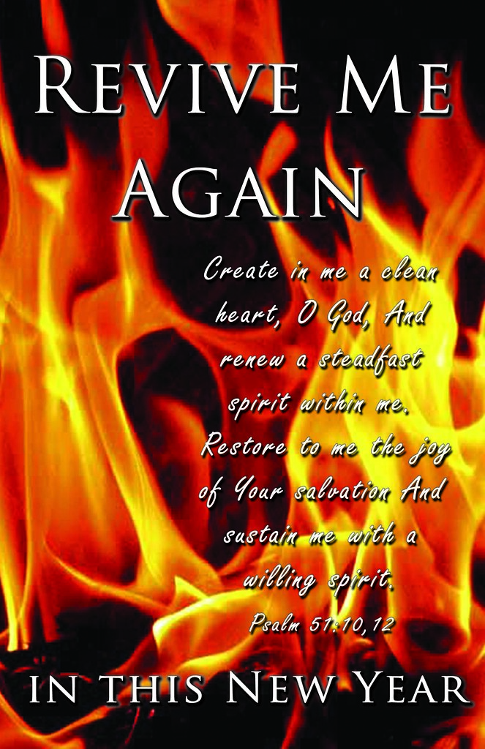

December 31, 2023
Service of Lessons and Carols

Welcome
Gathering Song O Come All Ye Faithful (ELW 279)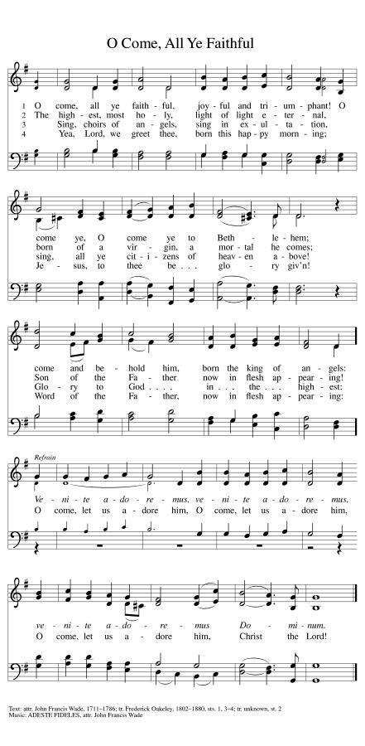
Dialogue
The people who walked in darkness have seen a great light
The light shines in the darkness, and the darkness has not overcome it
Those who dwelt in the land of deep darkness, on them light has shines
We have beheld Christ’s glory, glory as of the only Son from the Father.
To us a child is born, to us a Son is given
In the Word was Life, and the Life was the light of all people

Prayer
Almighty God, you have filled us with the new light of the Word who become flesh and lived among us. Let the light of our faith shine in all we do through your Son, Jesus Christ our Lord, who lives and reigns with you and the Holy Spirit, one God, now and forever.
Amen

Reading: Isaiah 9:2-7
2 The people who walked in darkness have seen a great light; those who lived in a land of deep darkness— on them light has shined.
3 You have multiplied the nation, you have increased its joy; they rejoice before you as with joy at the harvest, as people exult when dividing plunder.
4 For the yoke of their burden, and the bar across their shoulders, the rod of their oppressor, you have broken as on the day of Midian.
5 For all the boots of the tramping warriors and all the garments rolled in blood shall be burned as fuel for the fire.
6 For a child has been born for us, a son given to us; authority rests upon his shoulders; and he is named Wonderful Counselor, Mighty God, Everlasting Father, Prince of Peace.
7 His authority shall grow continually, and there shall be endless peace for the throne of David and his kingdom. He will establish and uphold it with justice and with righteousness from this time onward and forevermore. The zeal of the Lord of hosts will do this.

HYMN O Little Town of Bethlehem (V1-2)
O little town of Bethlehem,
How still we see thee lie
Above thy deep and dreamless sleep
The silent stars go by.
Yet in thy dark streets shineth
The everlasting light
The hopes and fears of all the years
Are met in thee tonight

For Chirst is born of Mary,
And, gathered all above
While mort als sleep, the angels keep
Their watch of wond’ring love.
O morning stars, together
Proclaim the holy birth
And praises sing to God the King,
And peach to all the earth.

Micah 5:2-5a
2 But you, O Bethlehem of Ephrathah,
who are one of the little clans of Judah,
from you shall come forth for me
one who is to rule in Israel,
whose origin is from of old,
from ancient days.
3Therefore he shall give them up until the time
when she who is in labor has brought forth;
then the rest of his kindred shall return
to the people of Israel.
4And he shall stand and feed his flock in the strength of the Lord,
in the majesty of the name of the Lord his God.
And they shall live secure, for now he shall be great
to the ends of the earth;
5and he shall be the one of peace.
If the Assyrians come into our land
and tread upon our soil,

HYMN O Little Town of Bethlehem (v3-4)
How silently, how silently
The wondrous gift is giv’n
So god imparts to human hearts
The blessings of his heav’n
No ear may hear his coming;
But, in the world of sin,
Where meek souls will receive him, still
The dear Christ enters in,

O holy child of Bethlehem,
Descend to us, we pray
Cast out our sin and enter in,
Be born in us today.
We hear the Christmas angels
The great glad tidings tell;
Oh, come to us, abide with us,
Our Lord Immanuel!

Reading Luke 1:26-35, 38

26 In the sixth month the angel Gabriel was sent by God to a town in Galilee called Nazareth,
27 to a virgin engaged to a man whose name was Joseph, of the house of David. The virgin's name was Mary.
28 And he came to her and said, "Greetings, favored one! The Lord is with you."
29 But she was much perplexed by his words and pondered what sort of greeting this might be.
30 The angel said to her, "Do not be afraid, Mary, for you have found favor with God.
31 And now, you will conceive in your womb and bear a son, and you will name him Jesus.
32 He will be great, and will be called the Son of the Most High, and the Lord God will give to him the throne of his ancestor David.
33 He will reign over the house of Jacob forever, and of his kingdom there will be no end."
34 Mary said to the angel, "How can this be, since I am a virgin?"
35 The angel said to her, "The Holy Spirit will come upon you, and the power of the Most High will overshadow you; therefore the child to be born will be holy; he will be called Son of God.
38 Then Mary said, "Here am I, the servant of the Lord; let it be with me according to your word." Then the angel departed from her

HYMN Angels from the Realms of Glory (v1-2) (ELW 275)

Angel, from the realms of glory,
Wing your flight o’er all the earth;
Once you sang creation’s story,
Now proclaim Messiah’s birth;
Come and worship, come and worship,
Worship Christ, the new-born king,

Shepherd, in the fields abiding,
Watching o’er your flocks by night.
God with us is now residing,
Yonder shines the infant light,
Come and worship, come and worship
Worship Christ, the new-born king,

Reading: Luke 2:1-7
1 In those days a decree went out from Emperor Augustus that all the world should be registered.
2 This was the first registration and was taken while Quirinius was governor of Syria.
3 All went to their own towns to be registered.
4 Joseph also went from the town of Nazareth in Galilee to Judea, to the city of David called Bethlehem, because he was descended from the house and family of David.
5 He went to be registered with Mary, to whom he was engaged and who was expecting a child.
6 While they were there, the time came for her to deliver her child.
7 And she gave birth to her firstborn son and wrapped him in bands of cloth, and laid him in a manger, because there was no place for them in the inn.

HYMN Angels from the Realms of Glory (v3-4) (ELW 275)
Sages, leave your contemplations,
Brighter visions beam afor:
Seek the great desire of nations,
You have seen his natal star.
Come worship, come and worship,
Worship Christ the new-born king

All creation, join in praisng
God, the Father, Spirit, Son,
Evermore your voices raising
Top the eternal Three in one.
Come and worship, come and worship,
Worship Christ, the new-born kingl

Reading Luke 2:8-20

8 In that region there were shepherds living in the fields, keeping watch over their flock by night.
9 Then an angel of the Lord stood before them, and the glory of the Lord shone around them, and they were terrified.
10 But the angel said to them, "Do not be afraid; for see—I am bringing you good news of great joy for all the people:
11 to you is born this day in the city of David a Savior, who is the Messiah, the Lord.
12 This will be a sign for you: you will find a child wrapped in bands of cloth and lying in a manger."
13 And suddenly there was with the angel a multitude of the heavenly host, praising God and saying,
14 "Glory to God in the highest heaven, and on earth peace among those whom he favors!"
15 When the angels had left them and gone into heaven, the shepherds said to one another, "Let us go now to Bethlehem and see this thing that has taken place, which the Lord has made known to us."
16 So they went with haste and found Mary and Joseph, and the child lying in the manger.
17 When they saw this, they made known what had been told them about this child;
18 and all who heard it were amazed at what the shepherds told them.
19 But Mary treasured all these words and pondered them in her heart.
20 The shepherds returned, glorifying and praising God for all they had heard and seen, as it had been told them.

HYMN The First Noel (ELW 300) (v1-2)
The first Noel the angel did say
Was to certain poor shephers in fields as they lay;
In fields where they lay, keeping their sheep,
On a cold winter’s night that was so deep.
Noel, Noel, Noel, Noel
Born is the King of Israel!

They looked up and saw a star
Shining in the east beyond them far;
And to the earth it gave great light,
And so it continued both day and night,
Noel, Noel, Noel, Noel
Born is the King of Israel!

Reading Luke 2:21-38
21 After eight days had passed, it was time to circumcise the child; and he was called Jesus, the name given by the angel before he was conceived in the womb.
22 When the time came for their purification according to the law of Moses, they brought him up to Jerusalem to present him to the Lord
23 (as it is written in the law of the Lord, "Every firstborn male shall be designated as holy to the Lord"),
24 and they offered a sacrifice according to what is stated in the law of the Lord, "a pair of turtledoves or two young pigeons."
25 Now there was a man in Jerusalem whose name was Simeon; this man was righteous and devout, looking forward to the consolation of Israel, and the Holy Spirit rested on him.
26 It had been revealed to him by the Holy Spirit that he would not see death before he had seen the Lord's Messiah.
27 Guided by the Spirit, Simeon came into the temple; and when the parents brought in the child Jesus, to do for him what was customary under the law,
28 Simeon took him in his arms and praised God, saying,
29 "Master, now you are dismissing your servant in peace, according to your word;
30 for my eyes have seen your salvation,
31 which you have prepared in the presence of all peoples,
32 a light for revelation to the Gentiles and for glory to your people Israel."
33 And the child's father and mother were amazed at what was being said about him.
34 Then Simeon blessed them and said to his mother Mary, "This child is destined for the falling and the rising of many in Israel, and to be a sign that will be opposed
35 so that the inner thoughts of many will be revealed—and a sword will pierce your own soul too."
36 There was also a prophet, Anna the daughter of Phanuel, of the tribe of Asher. She was of a great age, having lived with her husband seven years after her marriage,
37 then as a widow to the age of eighty-four. She never left the temple but worshiped there with fasting and prayer night and day.
38 At that moment she came, and began to praise God and to speak about the child to all who were looking for the redemption of Jerusalem.

HYMN The First Noel (v3-4)
And by the light of that same star
Three wise men cam from country far;
To seek for a king was their intent
And to follow the star wherever it went,
Noel, Noel, Noel, Noel
Born is the King of Israel!

This star drew nigh to the northwest,
O’er Bethlehem it took its rest;
And there it did both stop and stay
Right o’er the place where Jesus lay
Noel, Noel, Noel, Noel
Born is the King of Israel!

Reading Matthew 2:1-11

1 In the time of King Herod, after Jesus was born in Bethlehem of Judea, wise men from the East came to Jerusalem,
2 asking, "Where is the child who has been born king of the Jews? For we observed his star at its rising, and have come to pay him homage."
3 When King Herod heard this, he was frightened, and all Jerusalem with him;
4 and calling together all the chief priests and scribes of the people, he inquired of them where the Messiah was to be born.
5 They told him, "In Bethlehem of Judea; for so it has been written by the prophet:
6 "And you, Bethlehem, in the land of Judah, are by no means least among the rulers of Judah; for from you shall come a ruler who is to shepherd my people Israel.' "
7 Then Herod secretly called for the wise men and learned from them the exact time when the star had appeared.
8 Then he sent them to Bethlehem, saying, "Go and search diligently for the child; and when you have found him, bring me word so that I may also go and pay him homage."
9 When they had heard the king, they set out; and there, ahead of them, went the star that they had seen at its rising, until it stopped over the place where the child was.
10 When they saw that the star had stopped, they were overwhelmed with joy.
11 On entering the house, they saw the child with Mary his mother; and they knelt down and paid him homage. Then, opening their treasure chests, they offered him gifts of gold, frankincense, and myrrh.

HYMN The First Noel (V5)
Then entered in those wise men three,
Full reverently upon their knee,
And offered there in his presence
Their gold, and myrrh, and frankincense
Noel, Noel, Noel, Noel
Born is the King of Israel!

Reading Matthew 2:13-18

13 Now after they had left, an angel of the Lord appeared to Joseph in a dream and said, "Get up, take the child and his mother, and flee to Egypt, and remain there until I tell you; for Herod is about to search for the child, to destroy him."
14 Then Joseph got up, took the child and his mother by night, and went to Egypt,
15 and remained there until the death of Herod. This was to fulfill what had been spoken by the Lord through the prophet, "Out of Egypt I have called my son."
16 When Herod saw that he had been tricked by the wise men, he was infuriated, and he sent and killed all the children in and around Bethlehem who were two years old or under, according to the time that he had learned from the wise men.
17 Then was fulfilled what had been spoken through the prophet Jeremiah:
18 "A voice was heard in Ramah, wailing and loud lamentation, Rachel weeping for her children; she refused to be consoled, because they are no more."

HYMN What Child is This (ELW 296)

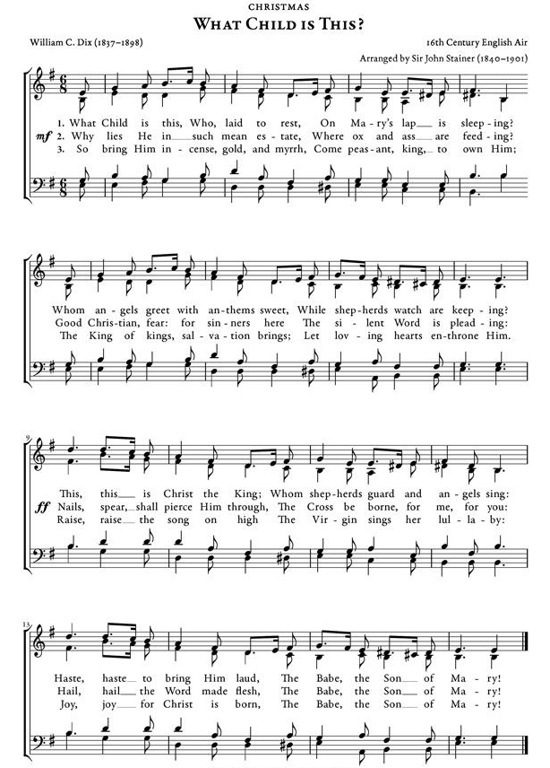
Reading John 1:1-14
1 In the beginning was the Word, and the Word was with God, and the Word was God.
2 He was in the beginning with God.
3 All things came into being through him, and without him not one thing came into being. What has come into being
4 in him was life, and the life was the light of all people.
5 The light shines in the darkness, and the darkness did not overcome it.
6 There was a man sent from God, whose name was John.
7 He came as a witness to testify to the light, so that all might believe through him.
8 He himself was not the light, but he came to testify to the light.
9 The true light, which enlightens everyone, was coming into the world.
10 He was in the world, and the world came into being through him; yet the world did not know him.
11 He came to what was his own, and his own people did not accept him.
12 But to all who received him, who believed in his name, he gave power to become children of God,
13 who were born, not of blood or of the will of the flesh or of the will of man, but of God.
14 And the Word became flesh and lived among us, and we have seen his glory, the glory as of a father's only son, full of grace and truth.

HYMN Hark! The Herald Angel Sing
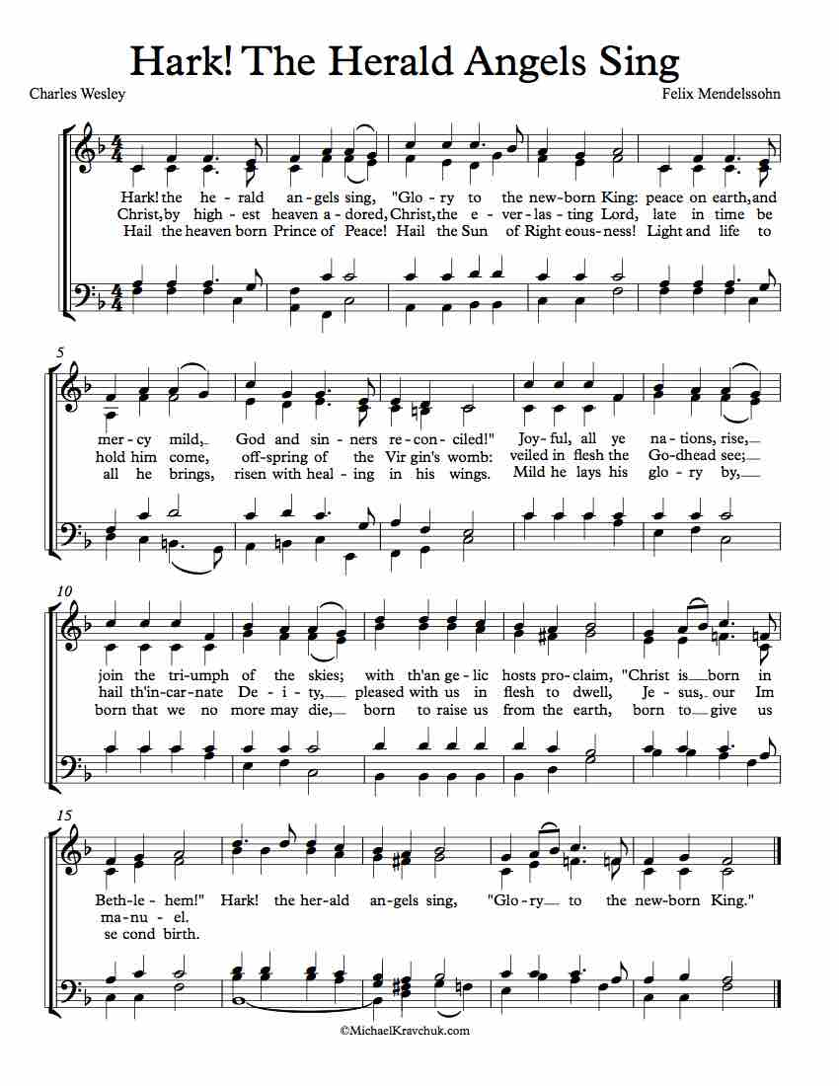
PRAYERS OF INTERCESSION
Joining our voices with the song of the angels, let us pray for the church, the world, and all who are in need,
Redeeming God, you gather together your people from the farthest parts of the earth. Protect your church from stumbling. Let it not be overcome by sorrow, division, or despair. Make us radiant with goodness, that we might live always to the praise of your glory. Hear us, O God
Your mercy is great
You bring together heaven and earth. All creation testifies to your splendor. Hold the ecosystems of this earth in delicate balance, from coastlands to farmlands, forests to wetlands. Deserts to rainforests. Show us new ways to live in harmony with the world around us. Hear us, O God.
Your mercy is great
You overflow with grace upon grace. .Expand the imaginations of those serve in positions of authority. Open their hearts to the needs of their nations and communities. Protect all those in harm’s way and those risking danger for the sake of others. Hear us, O God.
Your mercy is great
You bring consolation to those who weep, Embrace those who feel far-off, excluded, or defeated. Accompany those living with chronic and invisible illness. Sustain the weak and weary. Refresh those who labor under the weight of pain or sickness, Hear us, O God.
Your mercy is great
You come to us in the beauty of darkness and light Bring justice and reconciliation to communities divided by oppressions and misuse of power. Guide us to speak holy words of advocacy and truth. Help us to honor your image in one another, Hear us, O God
Your mercy is great
You turn our mourning into joy, We give thanks for those who have died in faith (especially). With all the saints, give us our inheritance in Christ. In the fullness of time, gather us all together in your mercy. Hear us, O God,
Your mercy is great
God of mercy, come quickly to us with grace upon grace as we lift these and all our prayers to you, in the name of Jesus.
Amen

OFFERING We Are An Offering (ELW 692)

We lift our voices
We lift our hands
We lift our lives up to you
We are an offering

Lord use our voices
Lord use our hands
Lord use our lives they are yours
We are an offering

All that we have
All that we are
All that we hope to be
We give to you
We give to you

We lift our voices
We lift our hands,
We lift our lives up to you
We are an offering
We are an offering

BLESSING & DISMISSAL
Let us bless the Lord.
Thanks be to God

May you be filled with the wonder of Mary,
The obedience of Joseph,
The joy of the angels,
The eag4erness off the shepherds,
The determination of the magi,
And thee peace of the Christ child.
Almighty God, Father & Son and Holy Spirit,
Bless you now and forever.
Amen

HYMN Go Tell it on the Mountain (ELW 290)

Refrain
Go tell it on the mountain,
Over the hills and everywhere;
Go tell it on the mountain
That Jesus Christ is born!

While shepherds kept their watching
Over silent flocks by night,
Behold, throughout the heavens
There shown aa holy light Refrain

The shepherds kept their watching
When, Lo, above the earth
Rang out the angel chorus
That nailed our Savior’s birth Refrain

Down in a lonely manger
The humble Christ was born;
And God sent us salvation
That blessed Christmas morn Refrain

ANNOUNCEMENTS

New members & old members please be in attendance on Jan 7th for installation of the new members and a Thank You to those going off.

Starting Sunday, January 7th at 6.00pm to 7:00pm “The Chosen” will be shown with a brief discussion afterwards. “The Chosen” is a historical drama based on the life of Jesus through the eyes of the ones who knew him.

January 28th we will be having our Annual Meeting Fellowship. Please bring a dish to share. If you have a report due, please get that in to the office by January 15th.

The new flower chart is up. Please sign up for next year

